**SQL PROJECT-2**

1. Write a query to create a route_details table using suitable data types for the fields, such as route_id, flight_num, origin_airport, destination_airport, aircraft_id, and distance_miles. Implement the check constraint for the flight number and unique constraint for the route_id fields. Also, make sure that the distance miles field is greater than 0.

**CODE:** create database customer;

use customer;

create table route_details(route_id int,flight_num int,origin_airport varchar(20),destination_airportvarchar(30),aircraft_idvarchar(20),distance int,check(flight_num is not null),unique(route_id),check(distance>0));

**OUTPUT:**

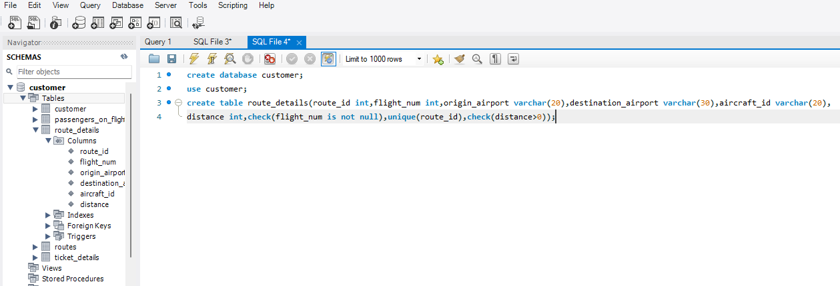

1. Write a query to display all the passengers (customers) who have travelled in routes 01 to 25. Take data from the passengers_on_flights table.

**CODE:** select * from passengers_on_flights where route_id between 1 and 25 ;

**OUTPUT:**

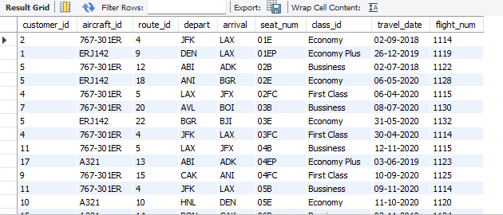

1. Write a query to identify the number of passengers and total revenue in business class from the ticket_details table.

**CODE:** select count(customer_id) as total_no_of_customers ,sum(price_per_ticket) as total_revenue from ticket_details where class_id="bussiness";

**OUTPUT:**

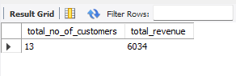

1. Write a query to display the full name of the customer by extracting the first name and last name from the customer table.

**CODE:** select concat(first_name , last_name) as full_name from customer;

**OUTPUT:**

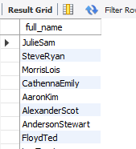

1. Write a query to extract the customers who have registered and booked a ticket. Use data from the customer and ticket_details tables.

**CODE**: select td.customer_id ,c.first_name,c.last_name from ticket_details as td

left join customer as c on td.customer_id=c.customer_id;

**OUTPUT:**

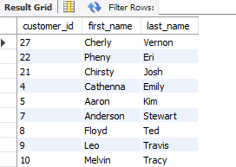

1. Write a query to identify the customer’s first name and last name based on their customer ID and brand (Emirates) from the ticket_details table.

**CODE:** select c.first_name,c.last_name,td.brand from ticket_details as td

left join customer as c on td.customer_id=c.customer_id where brand="emirates";

**OUTPUT:**

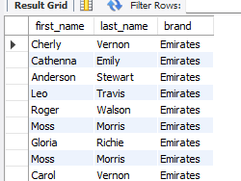

1. Write a query to identify the customers who have travelled by Economy Plus class using Group By and Having clause on the passengers_on_flights table.

**CODE:** select count(customer_id) as total_no_of_customers from passengers_on_flights group by class_id having class_id="economy plus";

**OUTPUT:**

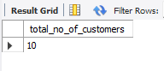

1. Write a query to identify whether the revenue has crossed 10000 using the IF clause on the ticket_details table

**CODE**: select if(sum(price_per_ticket)>10000 ,"yes,revenue is high","no") as revenue_check from ticket_details;

**OUTPUT:**

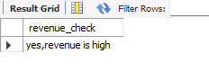

1. Write a query to create and grant access to a new user to perform operations on a database.

**CODE:** select user,host from mysql.user;

create user pooji@localhost;

show grants for pooji@localhost;

grant all on customer.* to pooji@localhost;

**OUTPUT:**

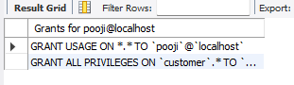

1. Write a query to find the maximum ticket price for each class using window functions on the ticket_details table.

**CODE:** with poojitha as(

select class_id,price_per_ticket as max_per_ticket,rank()over(partition by class_id order by price_per_ticket desc) as rank_ticket

from ticket_details )

select distinct * from poojitha where rank_ticket =1;

**OUTPUT:**

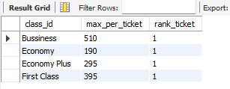

1. Write a query to extract the passengers whose route ID is 4 by improving the speed and performance of the passengers_on_flights table.

**CODE**: select pf.customer_id,c.first_name,c.last_name from passengers_on_flights as pf

left join customer c on pf.customer_id=c.customer_id where pf.route_id=4;

**OUTPUT:**

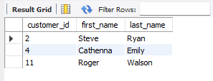

1. . For the route ID 4, write a query to view the execution plan of the passengers_on_flights table.

**CODE:** select aircraft_id,route_id,depart,arrival,flight_num from passengers_on_flights where route_id=4;

**OUTPUT:**

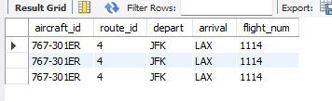

1. Write a query to calculate the total price of all tickets booked by a customer across different aircraft IDs using rollup function.

**CODE:** select sum(price_per_ticket),aircraft_id from ticket_details group by aircraft_id with rollup;

**OUTPUT:**

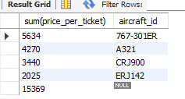

**14.** Write a query to create a view with only business class customers along with the brand of airlines.

**CODE:** create view busi_class as

select customer_id , brand from ticket_details where class_id="bussiness" ;

select * from busi_class;

**OUTPUT:**

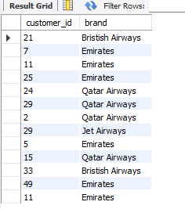

**15**.Write a query to create a stored procedure to get the details of all passengers flying between a range of routes defined in run time. Also, return an error message if the table doesn't exist.

**CODE:** create procedure GetPassengersByRouteRange(IN start_route INT, IN end_route INT)

begin

if exists (select 1 from passengers_on_flights) then

select * FROM passengers_on_flights

where route_id between start_route AND end_route;

else signal sqlstate '45000' set message_text = 'The table does not exist';

end if;

end

**OUTPUT:**

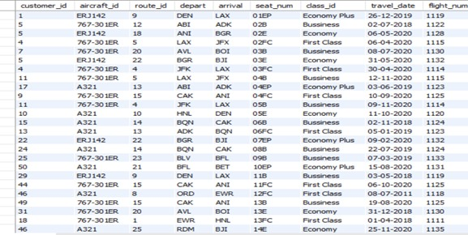

**16.** Write a query to create a stored procedure that extracts all the details from the routes table where the travelled distance is more than 2000 miles

**CODE:** Delimiter %%

create procedure distance()

begin

select * from routes where distance_miles>2000 ;

end%%

call distance;

**OUTPUT:**

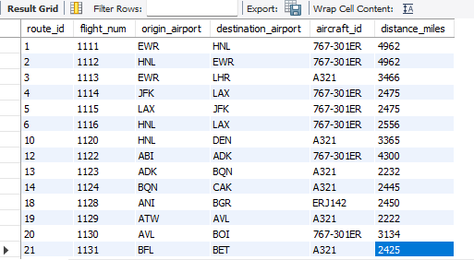

**17.** Write a query to create a stored procedure that groups the distance travelled by each flight into three categories. The categories are, short distance travel (SDT) for >=0 AND <= 2000 miles, intermediate distance travel (IDT) for >2000 AND <=6500, and long-distance travel (LDT) for >6500.

**CODE**: create procedure GroupDistanceTravel()

begin

select

flight_num,

case

when distance_miles between 0 and 2000 then 'sdt'

when distance_miles > 2000 and distance_miles <= 6500 then 'idt'

else 'ldt'

end as distance_category

from routes;

end

**OUTPUT:**

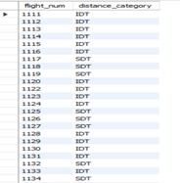 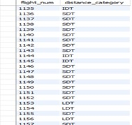 

**18.** Write a query to extract ticket purchase date, customer ID, class ID and specify if the complimentary services are provided for the specific class using a stored function in stored procedure on the ticket_details table. Condition:

● If the class is Business and Economy Plus, then complimentary services are given as Yes, else it is No

**CODE:**

delimiter //

create function get_complimentary_services(class_id varchar(20))

returns varchar(3)

deterministic

[1:52 pm, 8/27/2024] kavya besant: begin

declare result varchar(3);

if class_id = 'bussiness' or class_id = 'economy plus' then

set result = 'yes';

else

set result = 'no';

end if;

return result;

end; //

delimiter ;

code2:

create procedure display_ticket_details_with_services()

begin

select

p_date,

customer_id,

class_id,

get_complimentary_services(class_id) as complimentary_services

from ticket_details;

**OUTPUT:**

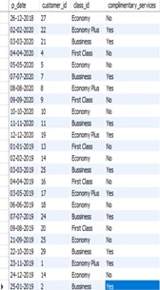 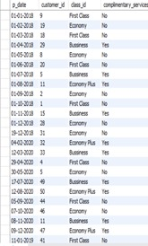 

**19.** Write a query to extract the first record of the customer whose last name ends with Scott using a cursor from the customer table.

**CODE:** create procedure getfirstscottcustomer()

begin

declare done int default 0;

declare c_id int;

declare c_first_name varchar(50);

declare c_last_name varchar(50);

declare cur cursor for

select customer_id, first_name, last_name

from customer

where last_name like '%scott';

declare continue handler for not found set done = 1;

open cur;

fetch cur into c_id, c_first_name, c_last_name;

if not done then

select c_id as customer_id, c_first_name as first_name, c_last_name as last_name;

else

select 'no customer with last name ending in scott' as message;

end if;

close cur;

end

**OUTPUT:**

